Google Analytics Drupal Module Implementation Guide

The ITrInno – Google Analytics Module allows the admin user to add Google Analytics to an open-source website.
The latest version of the module (6.x-3.3) is stored in the Framework SVN. This version of the module takes advantage of browser support for asynchronous JavaScript to enhance the speed in which the tracking code is loaded and provides integration with the Google Webmaster Tools product.
While the GA code can be hardcoded into Drupal templates, the Global Services Analytics Team always recommends the use of the GA module. The out-of-the-box module, when configured correctly, allows the application to provide basic reporting as well as advanced features such as event tracking and internal site search with minimal effort from the development team.
The actual Google Analytics tracking code is created by the GS Analytics Team and is provided to the development teams during the development cycle.
All active theme/template on the site should have a region named header within the HTML <head> element and 'print $scripts' to emit the JS.
Implementation Steps
Step 1: Enable the GA Module
The first step in the implementation process is for the GS developer to install and enable the GA module. This module can be found under Build -> Modules -> List
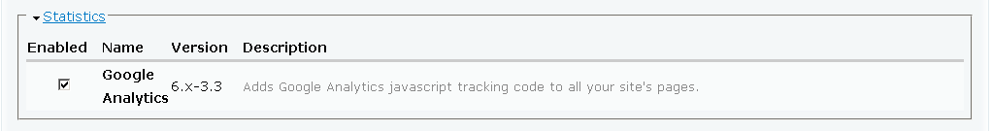
The 6.x-3.3-JNJ-1.1 module has been approved by the iTrInno Framework team and is available in the Framework SVN at http://itsusrasvn01.na.jnj.com/svn/ITrInno/CommunityBuild/GoogleAnalytics/
Once the developer copies the module to the server, they need to check the enable box to make it available to the application.
Step 2: Enter the Profile ID
Once the module has been enabled, the next step is to make some configuration changes. The GA module can be found under within the Settings menu.
The GS developer needs to enter the profile ID that was generated by the GS Analytics team into the box labeled Google Analytics account number:
Step 3: Configuration Options
The module has the ability for the developer to block the tracking code from specific pages. The GS Analytics Team recommends that we do not track the following pages:
Admin
admin/*
user/*/*
node/add*
node/*/*
Role specific tracking settings
The module allows the developer to assign tracking to specific roles. The GS Analytics Team recommends that none of these roles be checked so that we can track all users.

Link tracking settings
The module allows the developer to set various link tracking options. The GS Analytics Team recommends that the following items be checked for every project:
- Track outbound links - Enables tracking of clicks on outgoing links.
- Track mailto links -Enables tracking of clicks on mailto links.
- Track download links Enables tracking of clicks on links to files based on the file extensions list below.
These settings allow Drupal to automatically populate the Google Analytics Event Tracking reports for links to third-party sites as well and PDF and other binary file downloads.
The following files types are tracked out-of-the box:
7z|aac|avi|csv|doc|exe|flv|gif|gz|jpe?g|js|mp(3|4|e?g)|mov|pdf|phps|png|ppt|rar|sit|tar|torrent|txt|wma|wmv|xls|xml|zip
Additional file types can be appended to this list if required.
Step 4: Advanced Settings
Many of the open-source projects take advantage of the Google Search Appliance to provide internal search results. The GS module has an option to make the integration of GA and the GSA enabled by simply checking the Track internal search box under Advanced Settings.
Google has recently released a set of page speed reports in the version of Google Analytics. In order to take enable these reports, the following code needs to be inserted after the trackPageview call and can be done in the Custom JavaScript code section of the module:
_gaq.push(['_trackPageLoadTime']);
Finally, we want to make sure that the tracking code always is placed in the head section of the code. This is accomplished by selecting Header in the JavaScript scope section of the module:
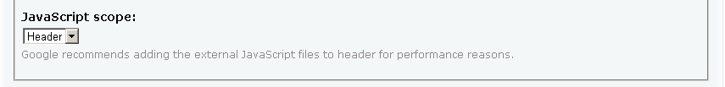
The GS Analytics Team recommends that both of these advanced options be enabled for all open-source projects.

Version | Changes
6.x-3.3-JNJ-1.1 | Upated to support GSA
6.x-3.3 | Asynchronous Tracking added to head tag. Tracking zero result searches
6.x-3.0 | Support for Asynchronous Tracking
6.x-2.2 | Dynamic title and description for user opt-in/-out setting, Support for try / catch (latest tracking code style)
6.x-2.0 | Download, Mail and Outgoing links are now tracked as Events

